**Lab 11:**

**MOSFET Amplifier Configurations**

Name: Wan-Yu Liao

ECEN 325 Section 514

TA: Mandela

Lab Date: November 15, 2019

Lab Report Due Date: November 19, 2019

**Calculation**

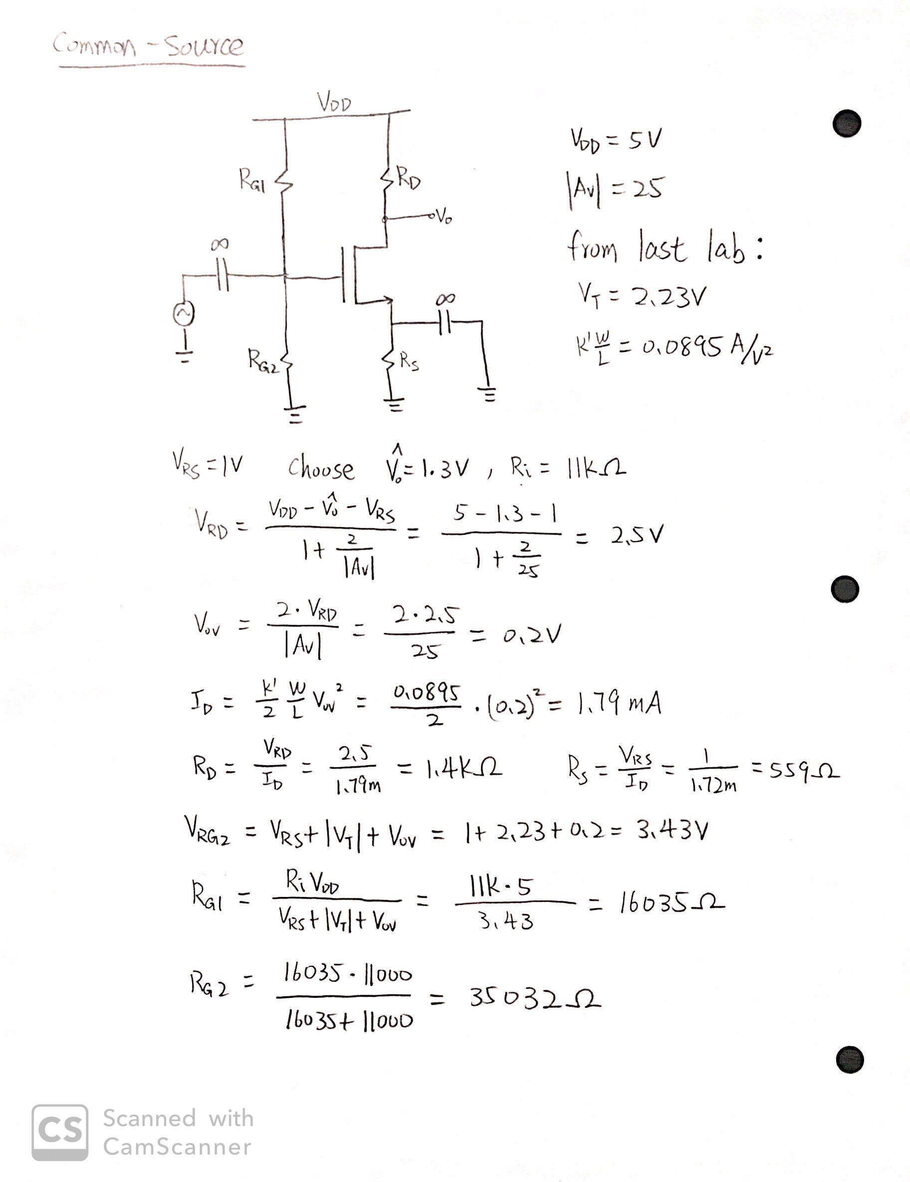

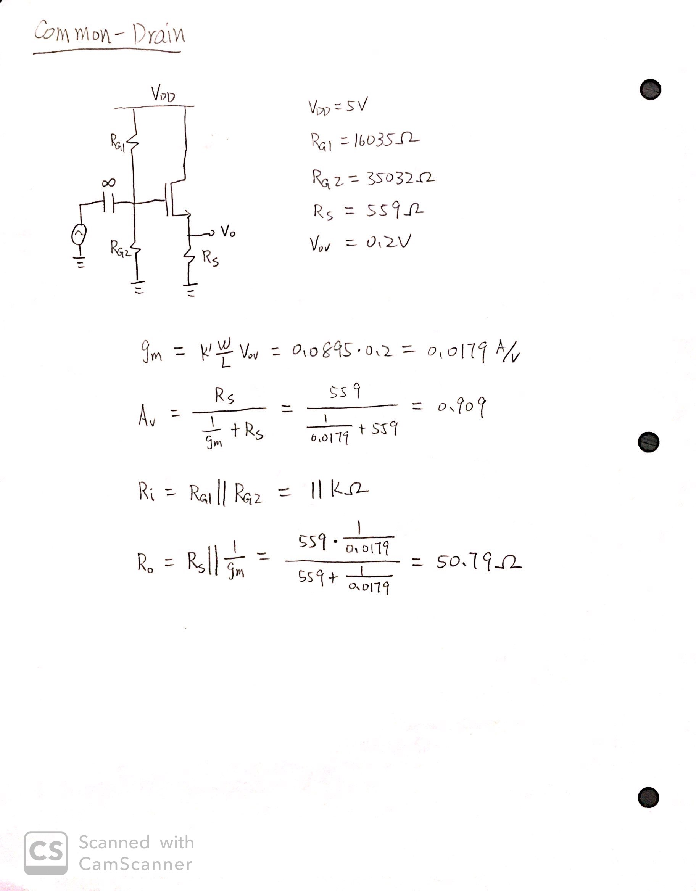

**Simulation**

Common-Source Amplifier

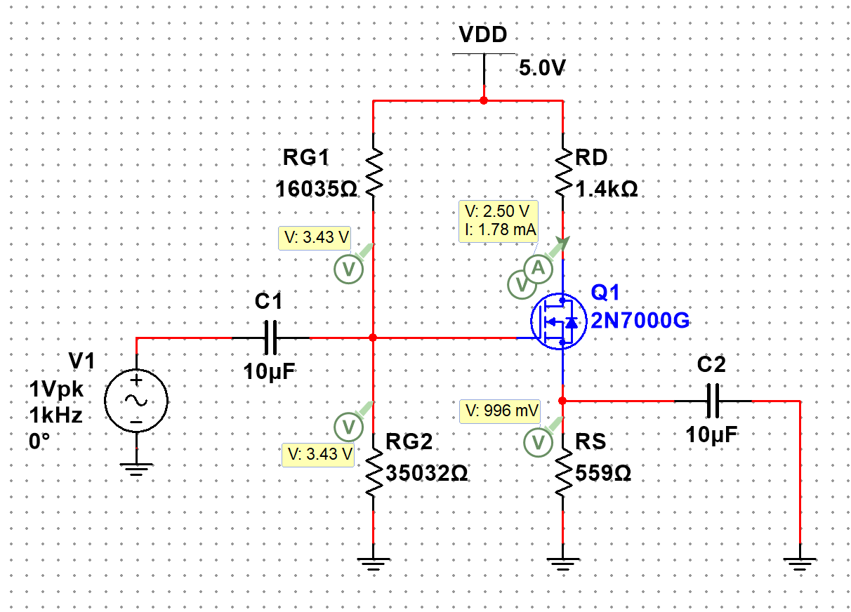

**Figure 1:** DC Solution for common-source amplifier ▲

VRG2 = 3.43V

VRS = 0.996V

VRD = 5-2.5 = 2.5V

Vo,dc = 2.5V

ID = 1.78mA

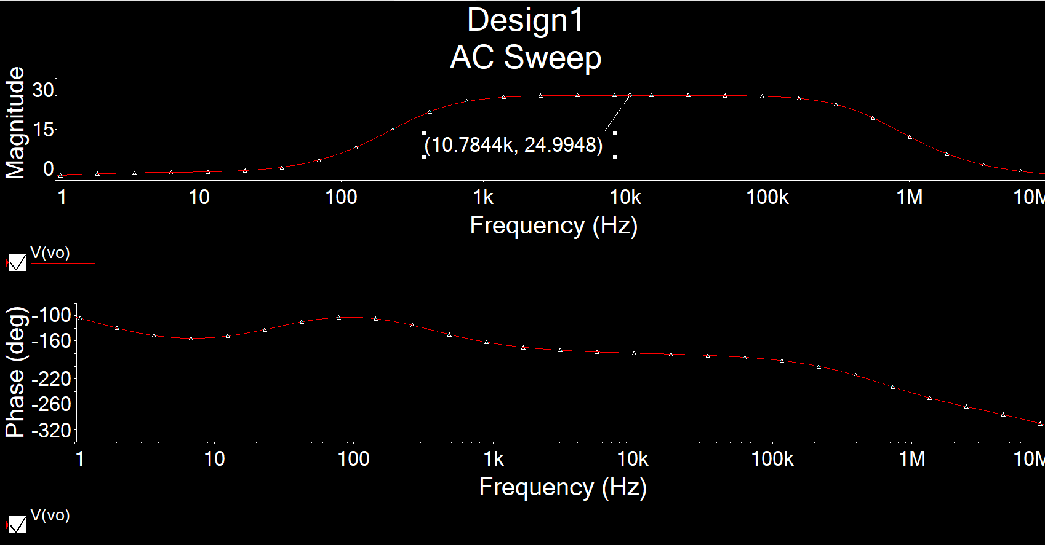

**Figure 2.1:** AC Simulation of AV for common-source amplifier ▲

AV = 24.9948

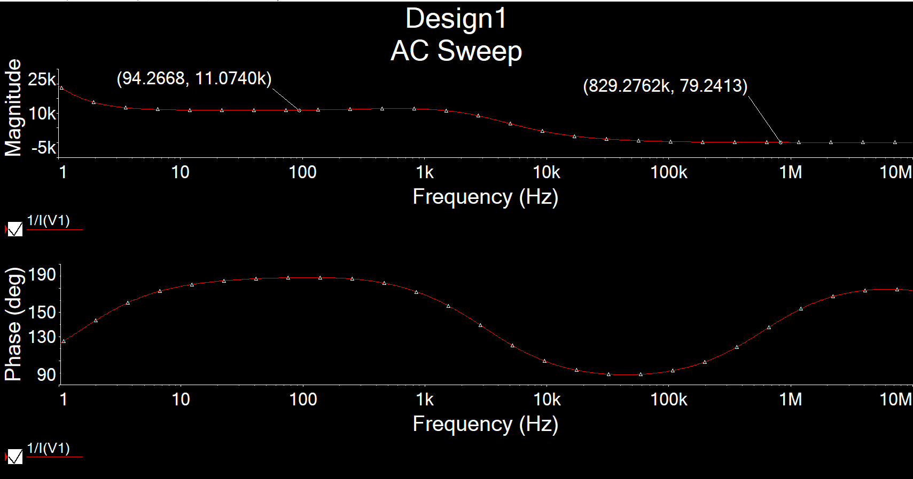

**Figure 2.2:** AC Simulation of Ri for common-source amplifier ▲

Ri = 11.0740kΩ

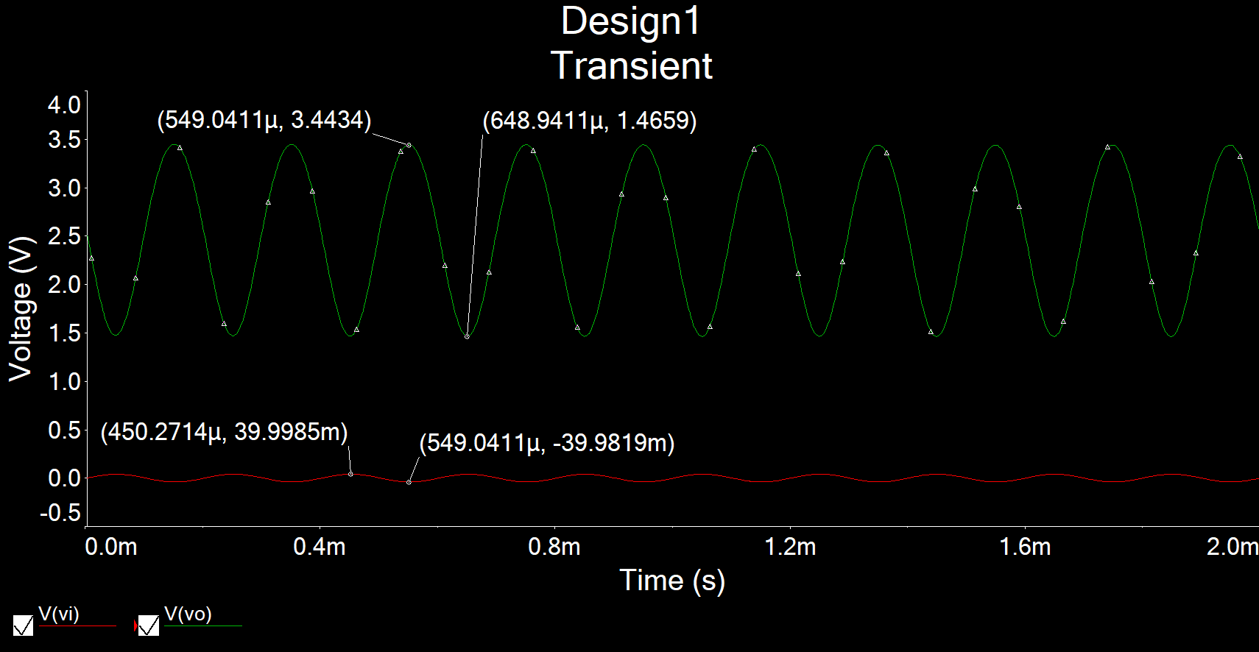

**Figure 3:** Time-domain waveform of Vi = 40mVfor common-source amplifier ▲

AV =

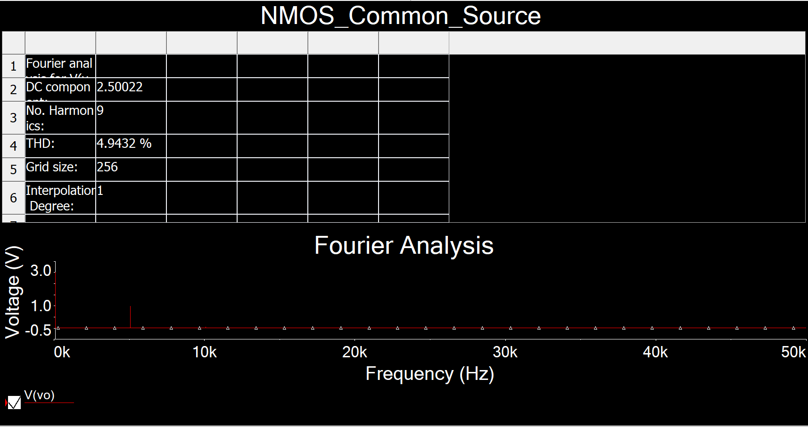

**Figure 4:** Total harmonic distortion (THD) for common-source amplifier ▲

THD = 4.9432% ≤ 5%

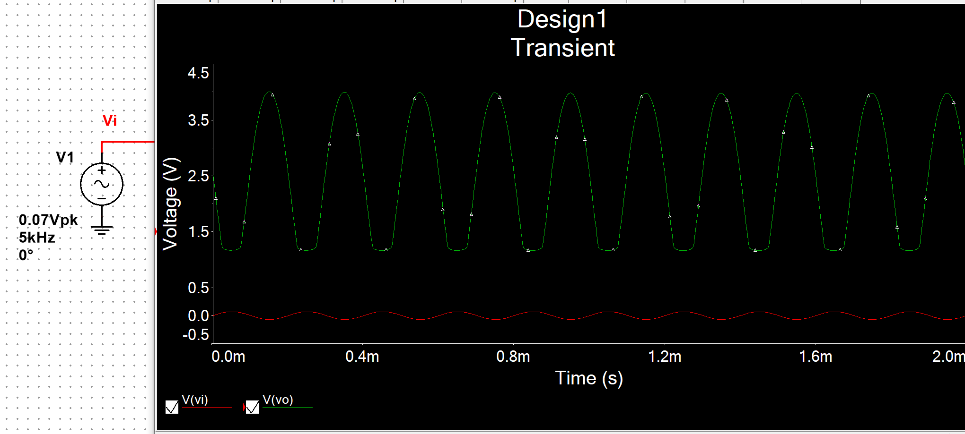

**Figure 5:** Clipping voltage for common-source amplifier ▲

Clipping voltage = 70mV

Common-Drain Amplifier

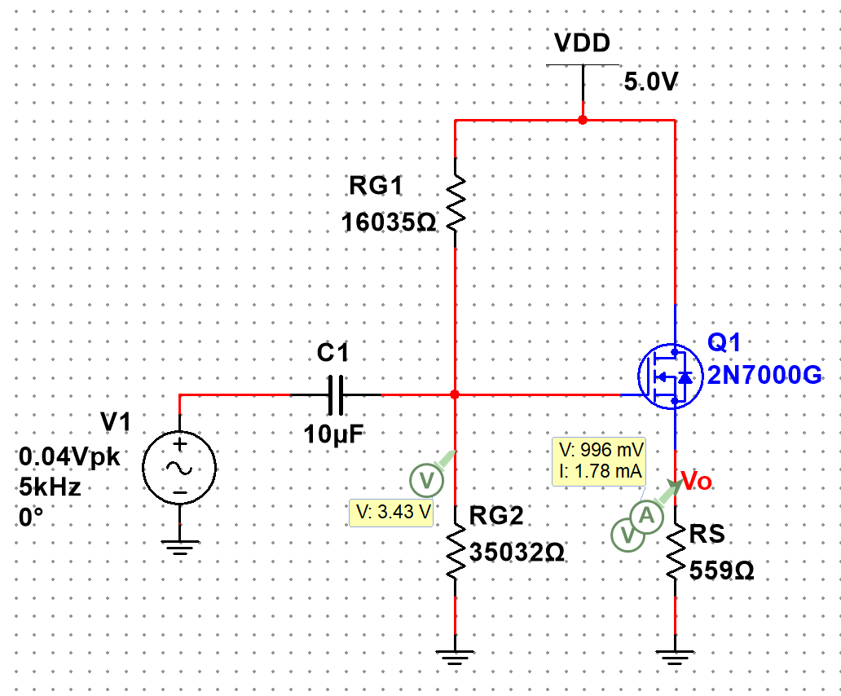

**Figure 6:** DC Solution for common-drain amplifier ▲

VRG2 = 3.43V

VRS = 0.996V

ID = 1.78mA

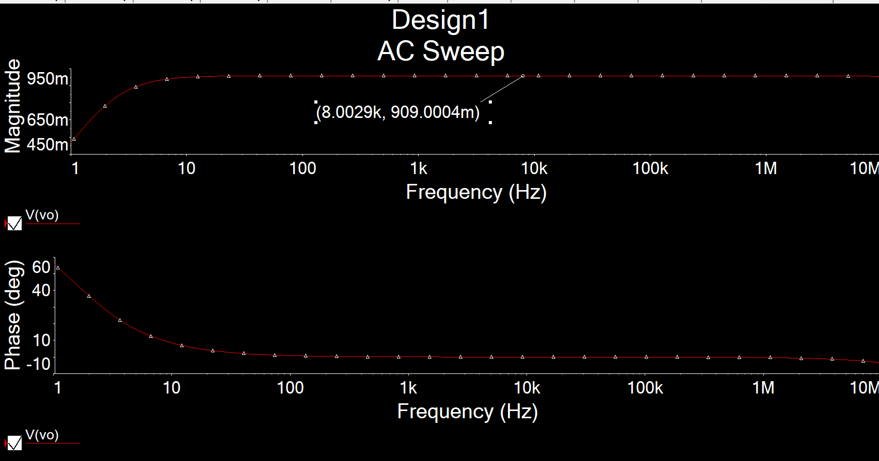

**Figure 7.1:** AC Simulation of AV for common-drain amplifier ▲

AV = 0.909

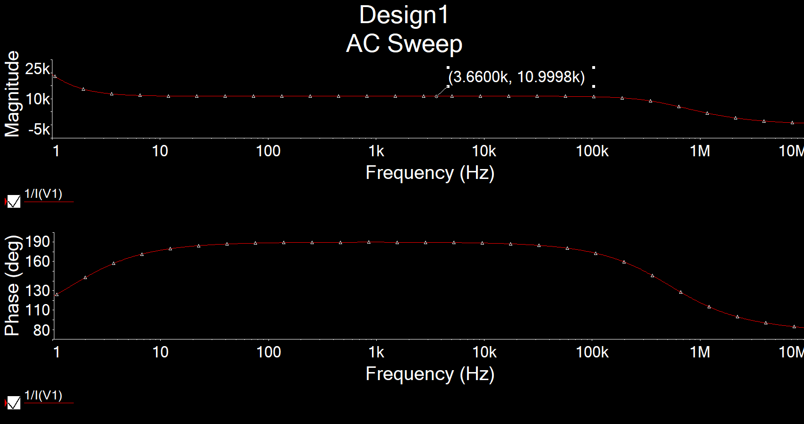

**Figure 7.2:** AC Simulation of Ri for common-drain amplifier ▲

Ri = 10.9998kΩ

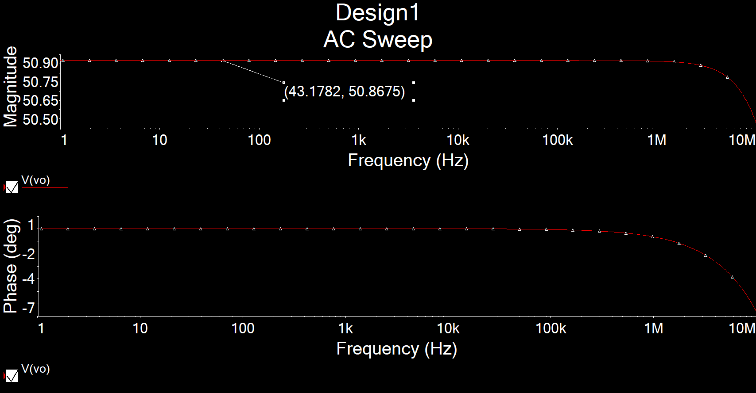

**Figure 7.3:** AC Simulation of Ro for common-drain amplifier ▲

Ro = 50.8675Ω

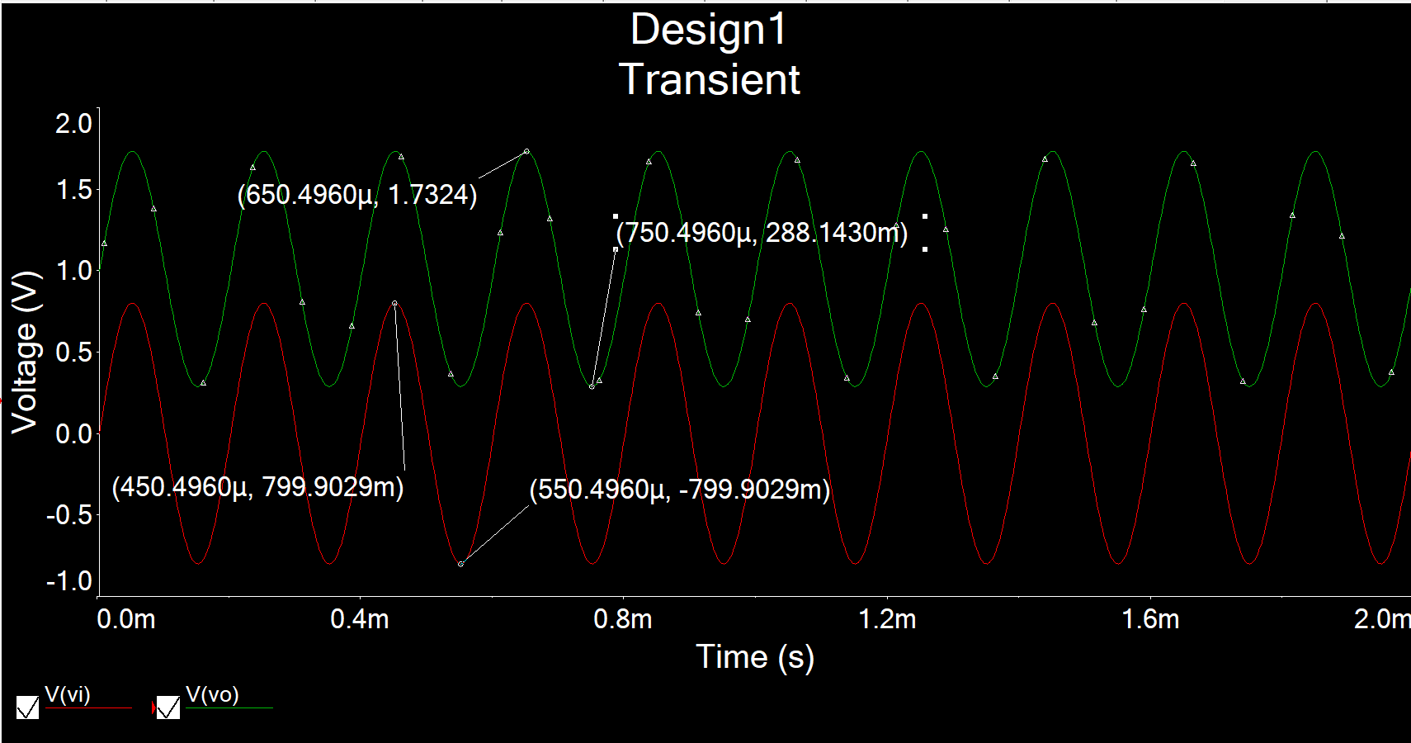

**Figure 8:** Time-domain waveform of Vi = 0.8Vfor common-drain amplifier ▲

AV =

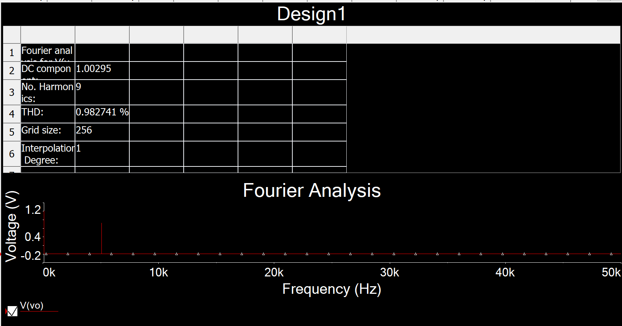

**Figure 9:** Total harmonic distortion (THD) for common-drain amplifier ▲

THD = 0.983%

**Measurement**

Common-Source Amplifier:

DC Solutions:

VRG2 = 3.276V, VRS = 1.082V, VRD = 5-2.31 = 2.69V, Vo,dc = 2.31V, ID = 2.69/1.4k = 1.92mA

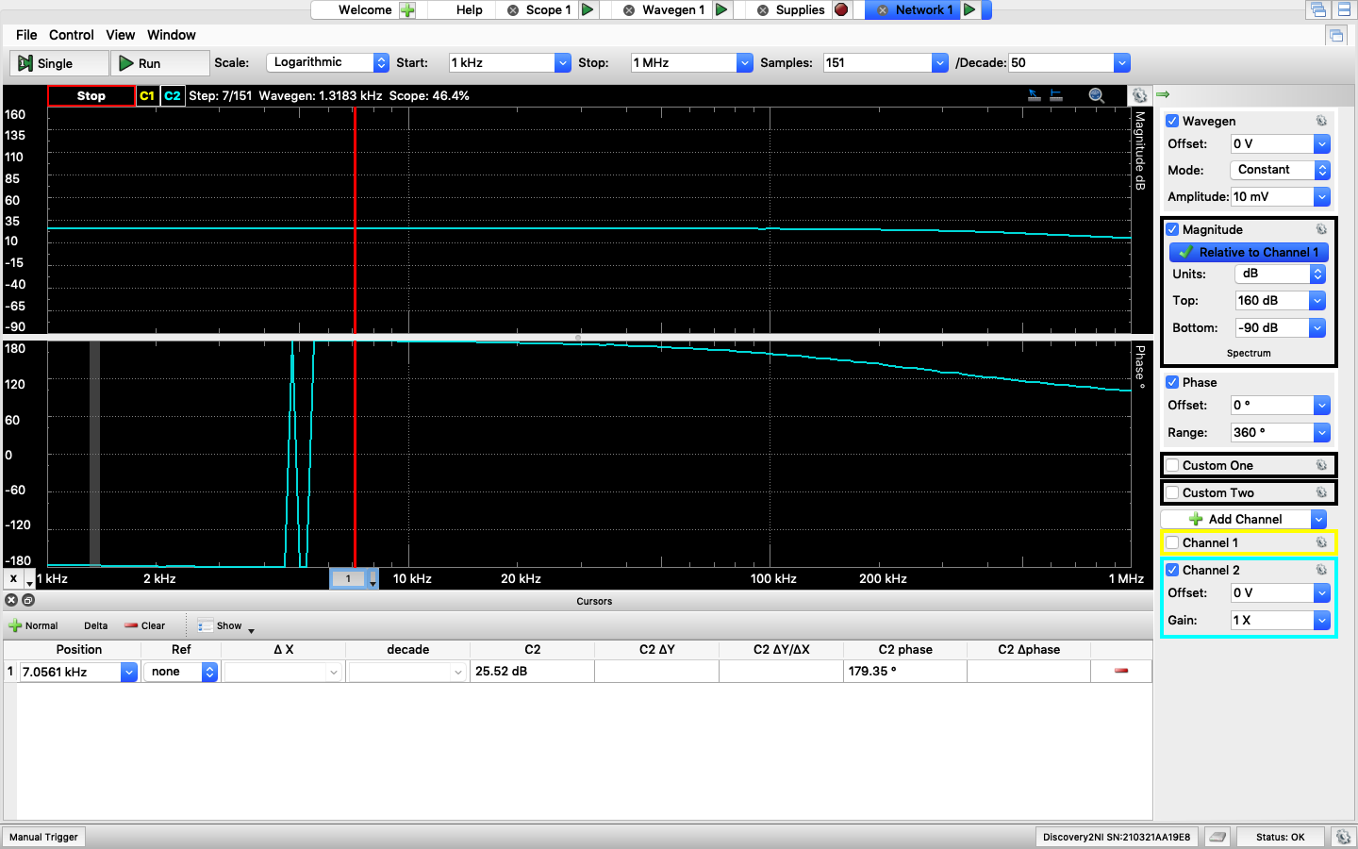

**Figure 10.1:** AC Simulation of AV for common-source amplifier ▲

AV = 25.52dB = 18.88

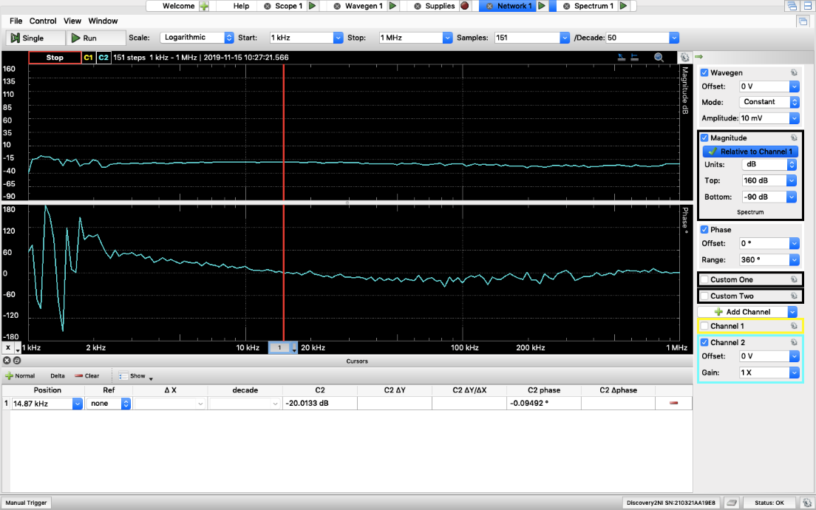

**Figure 10.2:** AC Simulation of Ri for common-source amplifier ▲

Ri / ( Ri + Rtest) = -20.0133dB = 0.0998 => Rtest = 10kΩ, Ri = 1108Ω

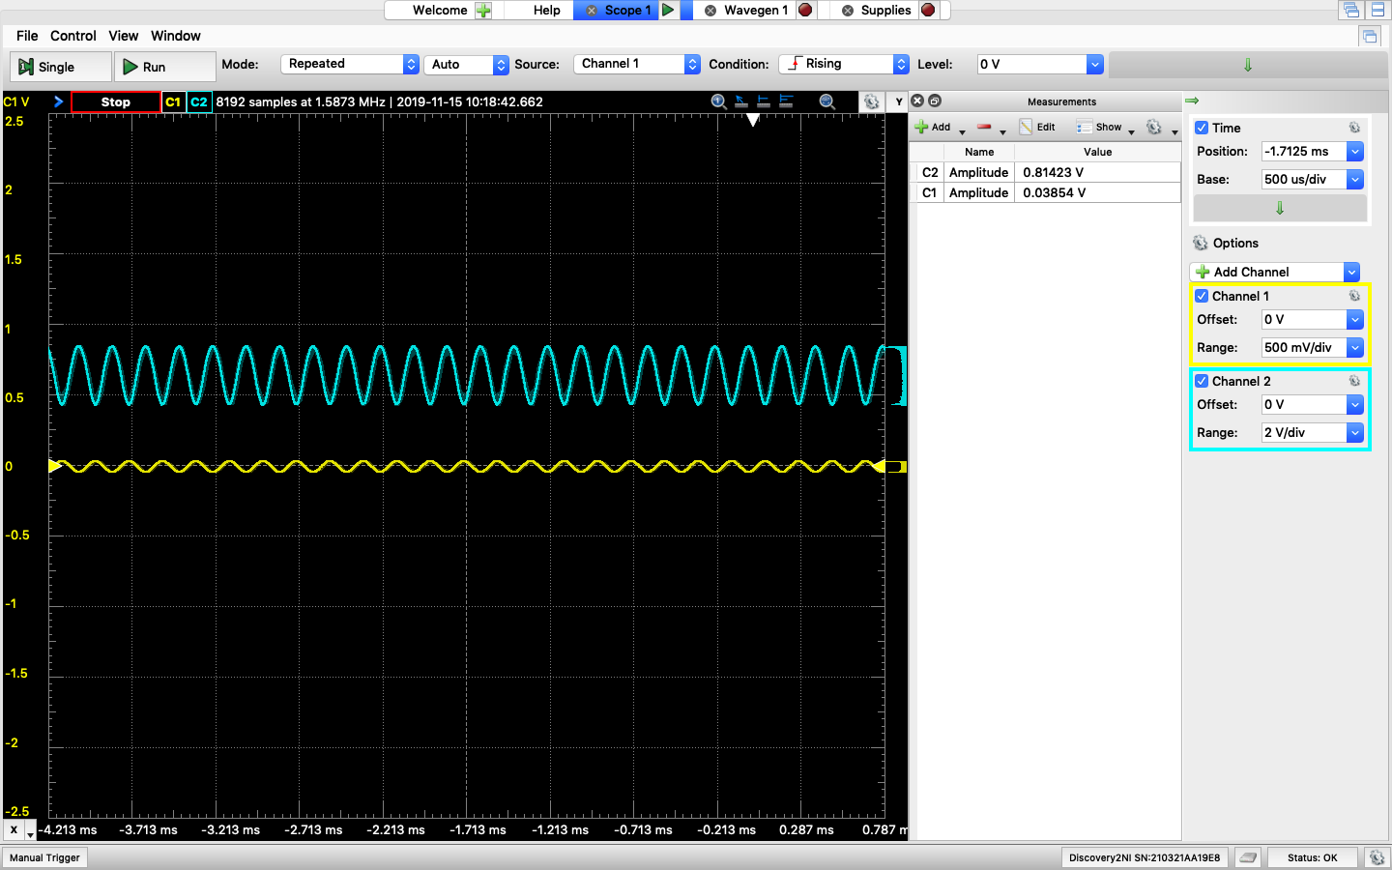

**Figure 11:** Waveform simulationfor common-source amplifier ▲

AV = 0.81/0.038 = 21.32

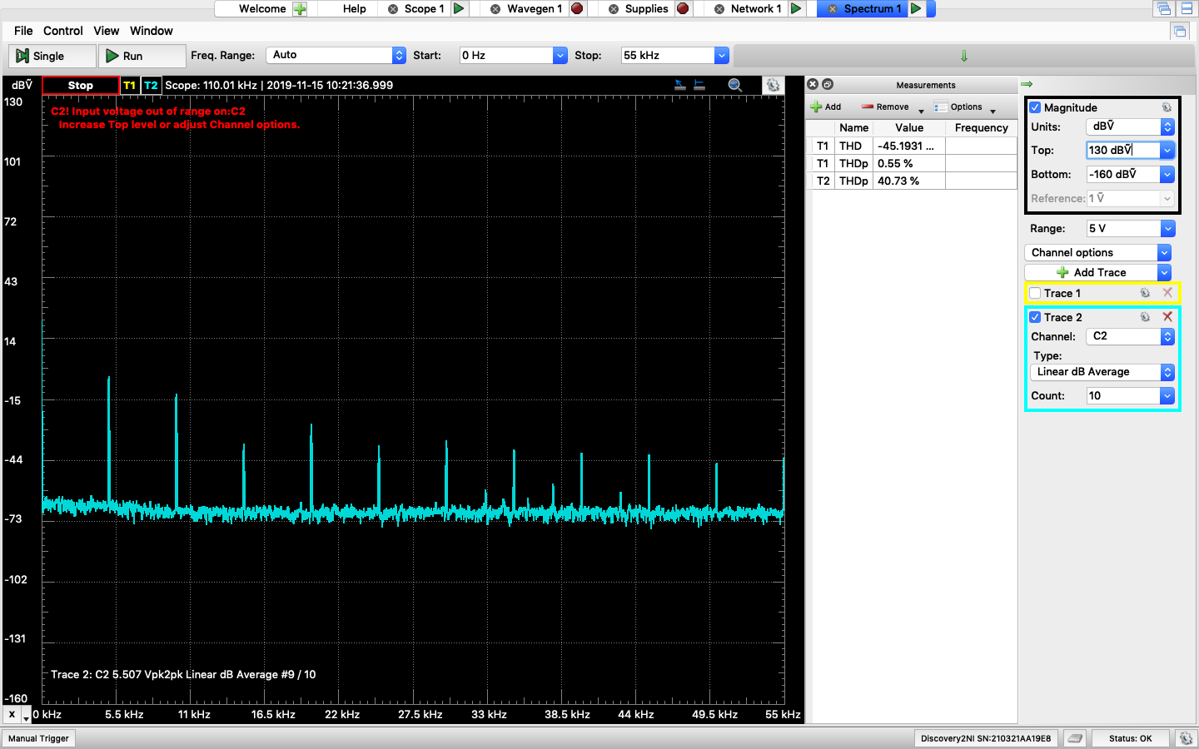

**Figure 12:** THDfor common-source amplifier ▲

THD = 40.73%

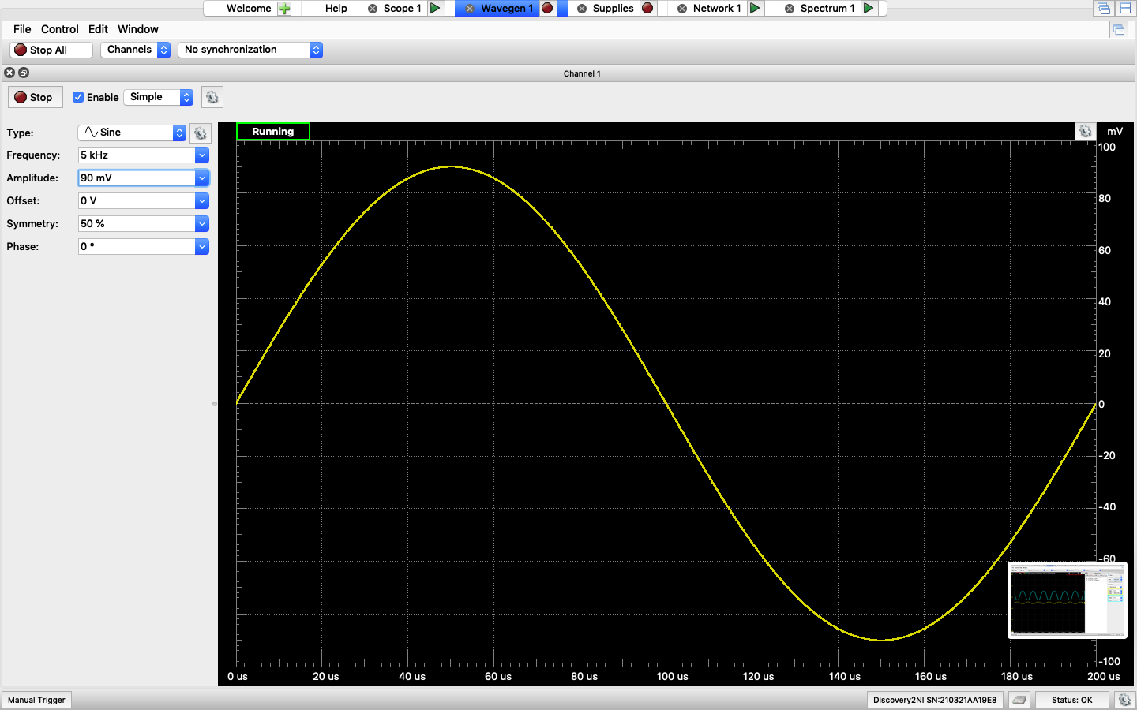

**Figure 13.1:** Vi of clipping voltage for common-source amplifier ▲

Vi clipping = 90mV

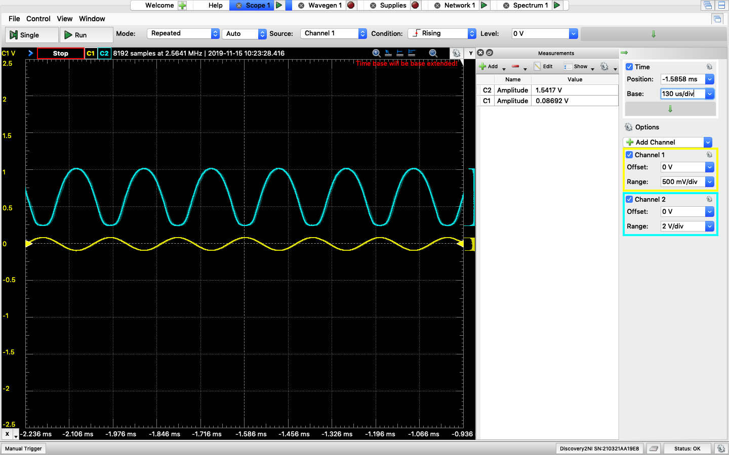

**Figure 13.2:** Waveformof clipping voltage for common-source amplifier ▲

Common-Drain Amplifier:

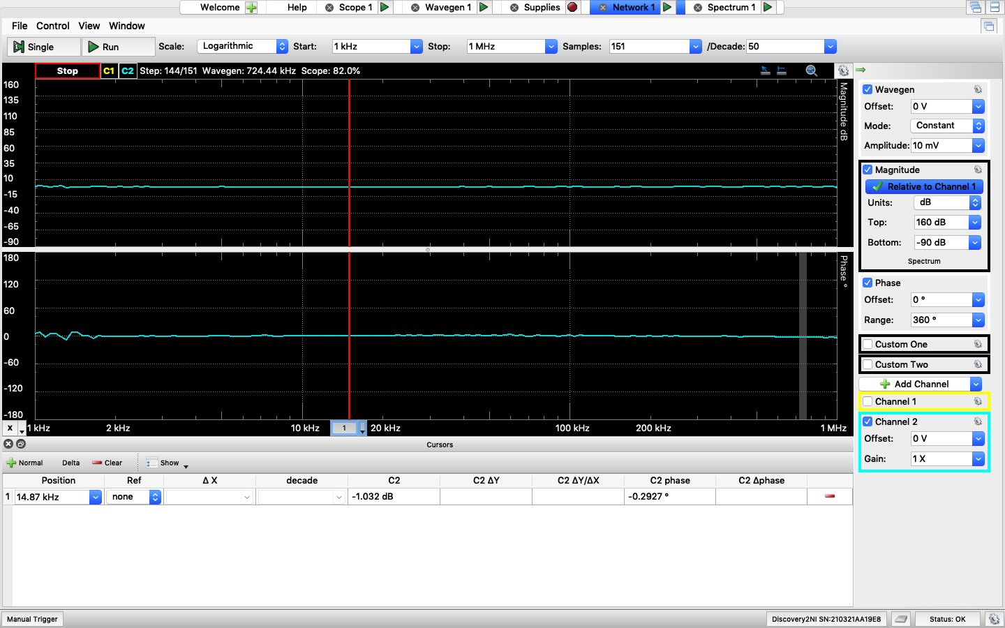

**Figure 14.1:** AC Simulation of AV for common-drain amplifier ▲

AV = -1.032dB = 0.888

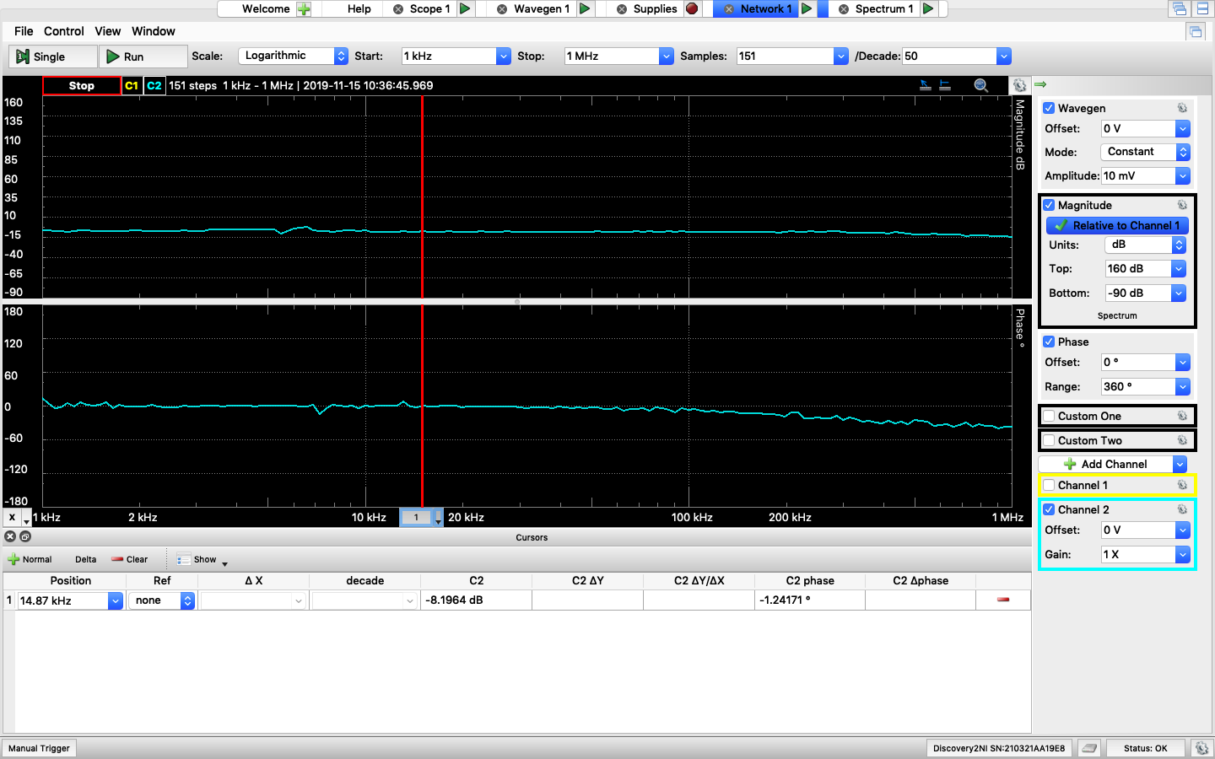

**Figure 14.2:** AC Simulation of Ri for common-drain amplifier ▲

Ri / ( Ri + Rtest) = -8.2dB = 0.389 => Rtest = 10kΩ, Ri = 6366Ω

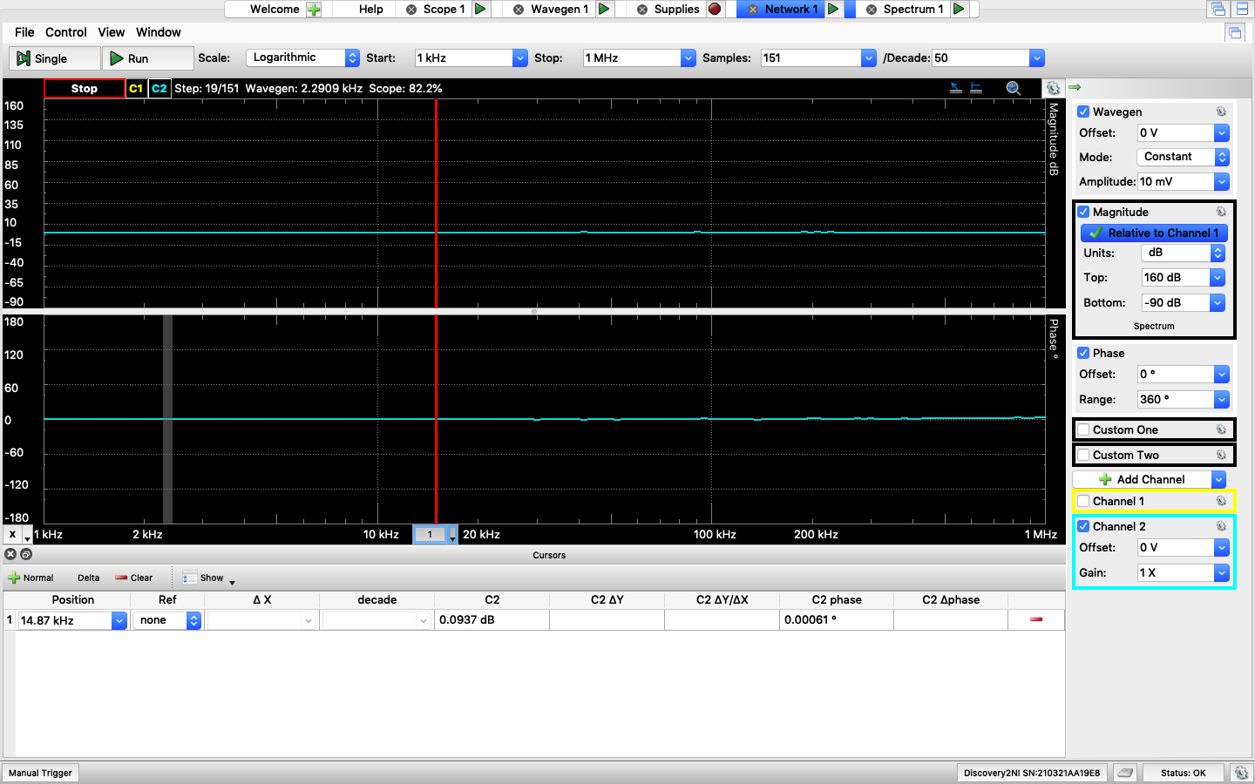

**Figure 14.3:** AC Simulation of Ro for common-drain amplifier ▲

Ro / ( Ro + Rtest) = 0.0937dB = 1.01 => Rtest = 1kΩ, Ro = -10.1kΩ (Impossible)

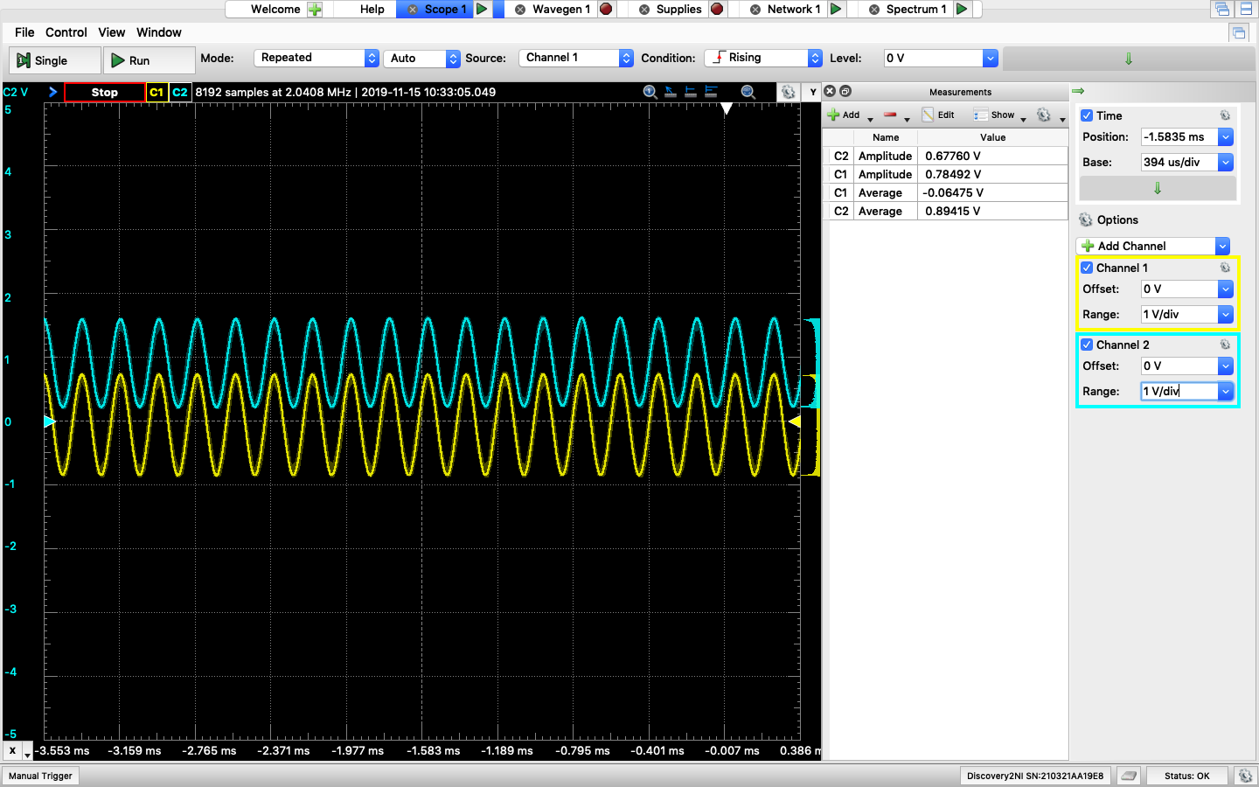

**Figure 15:** Waveformfor common-drain amplifier ▲

AV = 0.67760/0.78492 = 0.863

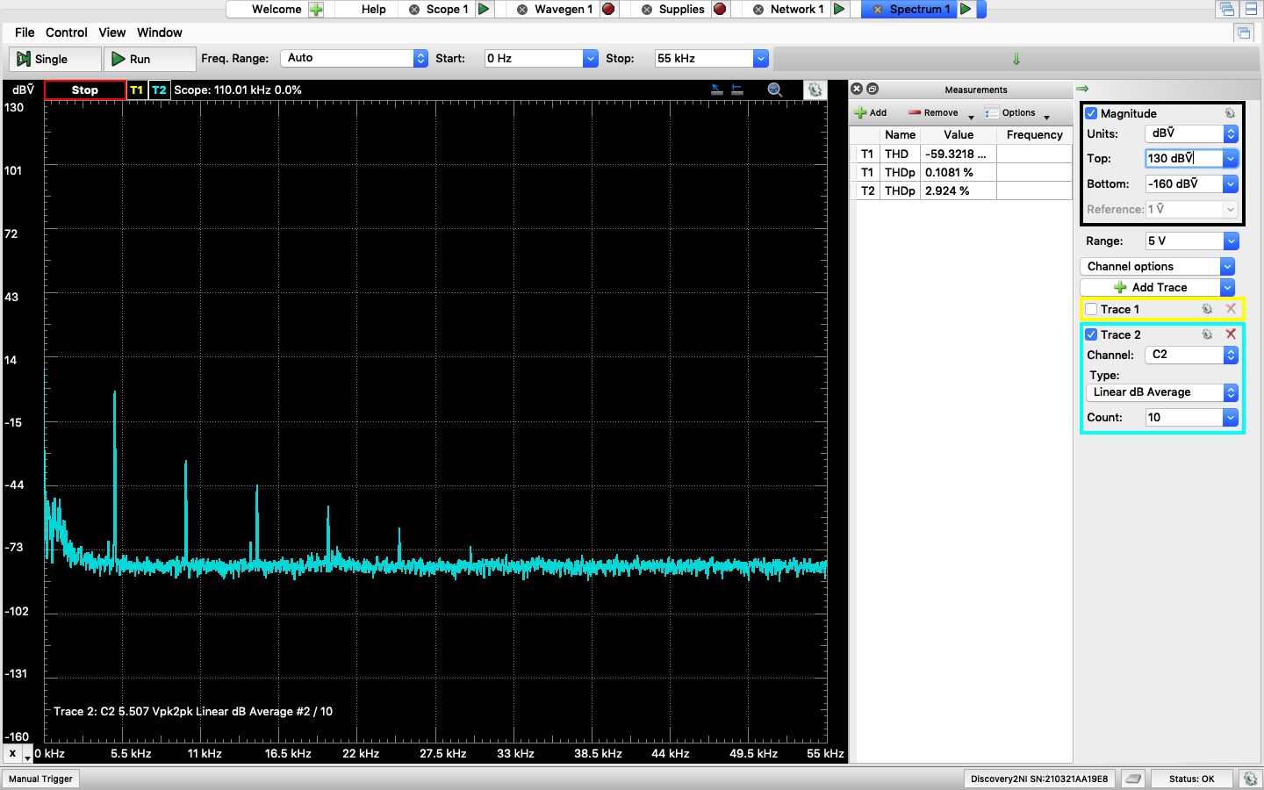

**Figure 16:** THDfor common-drain amplifier ▲

THD = 2.924%

**Table**

**Common-Source Amplifier**

|  |  |  |  |
| --- | --- | --- | --- |
|  | **Calculation** | **Simulation** | **Measurement** |
| **VRG2** | 3.43V | 3.43V | 3.27V |
| **VRS** | 1V | 0.996V | 1.082V |
| **VRD** | 2.5V | 2.5V | 2.69V |
| **Vo,dc** | 2.5V | 2.5V | 2.31V |
| **ID** | 1.79mA | 1.78mA | 1.92mA |
| **AV** | 25 | 24.9948 | 21.32 |
| **Ri** | 11kΩ | 11.0740kΩ | 1108Ω |
| **THD** |  | 4.9432% | 40.73% |

**Common-Drain Amplifier**

|  |  |  |  |
| --- | --- | --- | --- |
|  | **Calculation** | **Simulation** | **Measurement** |
| **VRG2** | 3.43V | 3.43V | 3.19V |
| **VRS** | 1V | 0.996V | 1.07V |
| **ID** | 1.79mA | 1.78mA | 1.91mA |
| **AV** | 0.909 | 0.909 | 0.863 |
| **Ri** | 11kΩ | 10.9998kΩ | 6366Ω |
| **Ro** | 50.97Ω | 50.8675Ω | -10.1kΩ (impossible) |
| **THD** |  | 0.983% | 2.924% |

**Comment**

Overall, calculation values and simulation values are very similar. For measurement, I used different β and VT values for 2N7000 transistor to calculate resistor values since I got different β and VT values for measurement part from Lab 10. However, for common-source amplifier, it only gave me a gain of 21.32 which is not close to 25. This might because the real-world components do not act as ideal cases and the power consumption limit of Analog Discovery 2. Also, the output resistor for common-drain amplifier is negative which is impossible.